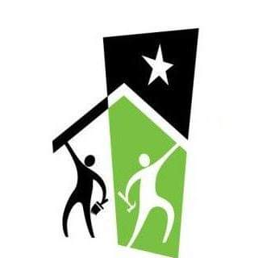
Rebuilding Together
Tri-County

PO Box 1111
Okemos MI 48805-1111
517 445-5068
http:\\www.rebuildtogethertricounty.com
Your donation is tax deductible.
Rebuilding Together Tri-County is a 501C3 non-profit.
Donation:
Address

Email

